Gender pay report 2017
Introduction

This report contains Imagine Act and Succeeds statutory disclosure of the gender pay gap.

All companies with 250 or more employees are now required to publish their gender pay gap under new legislation that came into force in April 2017. This is different to Equal Pay regulations which require employers to offer equal pay for equal jobs.

The regulations state that employers must report on their gender pay gap, gender bonus pay gap and they must also, based on pay, split equally all of their employees into four groups, these are called quartiles.

The regulations state that employers have to publish their pay gap and bonus pay gap between men and women in two ways, they are:

On a mean basis – an average hourly salary of each gender

On a median basis – pay per hour based on the person in the middle of the distribution of pay of each gender.

Employers are also required to disclose the distribution of gender by quartiles, this is done by splitting the workforce into four groups based on their pay, showing the percentage of men and women in each group.

Imagine Act and Succeed welcomes and supports gender pay gap reporting.

The Gender Pay Gap

According to the Office of National Statistics (ONS) in 2016 the national gender gap was 18%.

The overall gender pay gap in Imagine Act and Succeed, at the 5 April 2017, is 0% on a median basis and -5.92% on a mean basis.

As an organisation we employ significantly more females than males overall, with the majority of our management team being female.

-5.92%
The overall gender pay gap on a mean basis as at 5 April 2017 as per the gender pay gap regulations

0%
The overall gender pay gap on a median basis as at 5 April 2017 as per the gender pay gap regulations

Imagine Act and Succeed have significantly more females than males employed, and although the gender distribution stays steady through most quartiles with the Upper Quartile is heavily biased towards females, this is a reflection of our management team.

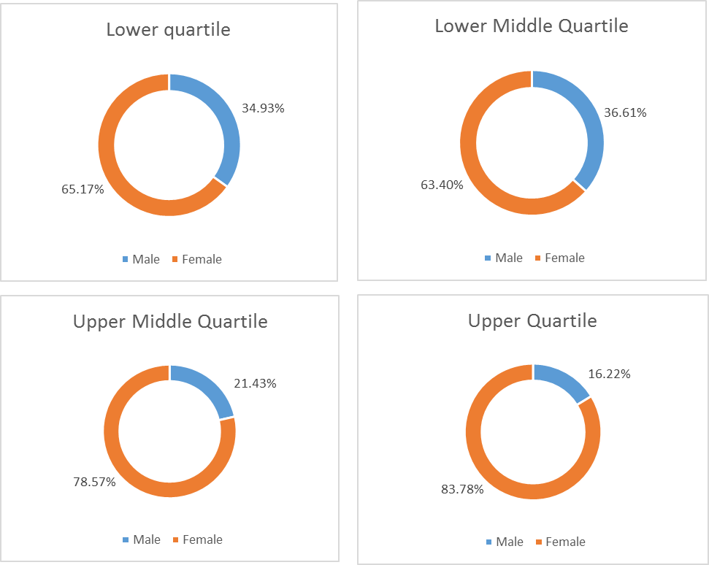

Gender Bonus Gap Reporting

Within Imagine Act and Succeed, no employee received a bonus, therefore there is no data to record and by default both the mean and median bonus gender gap is 0%

0%
The overall gender bonus pay gap on a mean basis as at 5 April 2017 as per the gender pay gap
0%
The overall gender bonus pay gap on a median basis as at 5 April 2017 as per the gender pay gap regulations

Gender pay reporting is a different concept to equal pay, and Imagine Act and Succeed have always paid, and will continue to pay, an equal pay for equal work, our pay grades are based on the job role and not the gender of the person.

As an organisation, we have always strived to employ, the right person for the right role and we pride ourselves on ensuring people who are recruited will bring value to the people we support and the organisation, and to do this we offer as much flexibility as possible and practical. This allows us to have a diverse pool of employees.

72% of our total workforce are female and we have a management team with a higher proportion of female than male. Therefore, it makes sense that female staff would out-weigh male staff in all quartiles.

Although we agree with the principles of the gender pay reporting legislation as laid out in the equality act, and have reported in line with this. As an organisation we do not want to focus too heavily on the gaps and how we close them, but to ensure all our roles are accessible to both genders, and we will review how we can encourage more males to apply for more senior roles within the organisation. We want to continue to ensure that the right people are recruited into the right roles as this achieves the best outcome for the people we support and our staff.

Sharon Walsh
Human Resources Manager

